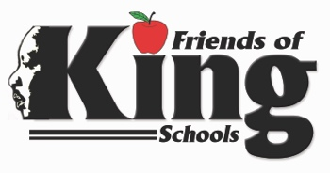
1617 Caffin Avenue, NOLA 70117
James Mack (504) 940-2243 Fax: ( 504) 940-2276
Principal

March 3, 2024

Dear Parents,

We value parent involvement at our schools and our staff believes that effective and engaging parent involvement is critical for every child's success. This letter is an invitation to serve on the Friends of King. Title 1 Parent Advisory Board.
This committee will participate in planning meetings to develop parent programs and activities that will be implemented for the upcoming school year. Your input is valuable as we develop activities, workshops and events to help all Title 1 parents be full partners in the education of our children. This input from this meeting will be used to update our Parent and Family Engagement Policy and School’s Compact.
Will you consider volunteering a small portion of your time by becoming a member of the Parent Advisory Board? Please complete the attached form and return it to your child's teacher.

-----------------------------------Please Return-------------------------------
__________________________ ____________________________
Parent Name Student Name
_________________________ ___________________________
Phone Number Email Address
______ I would like to be a member of the Parent Advisory Board.
Best time for me to meet: ________Morning ______Afternoon ______Evening

