**WELCOME PARENTS, EMPLOYEES & THE COMMUNITY**

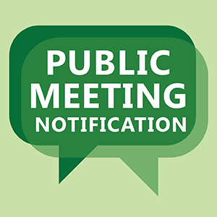

**FRIENDS OF KING SCHOOLS**

**BOARD OF DIRECTORS MEETING TUESDAY, OCTOBER 8, 2014 (12 NOON) DR. MLK ELEM. SCHOOL LIBRARY**