2024-2025 Board Meeting Schedule
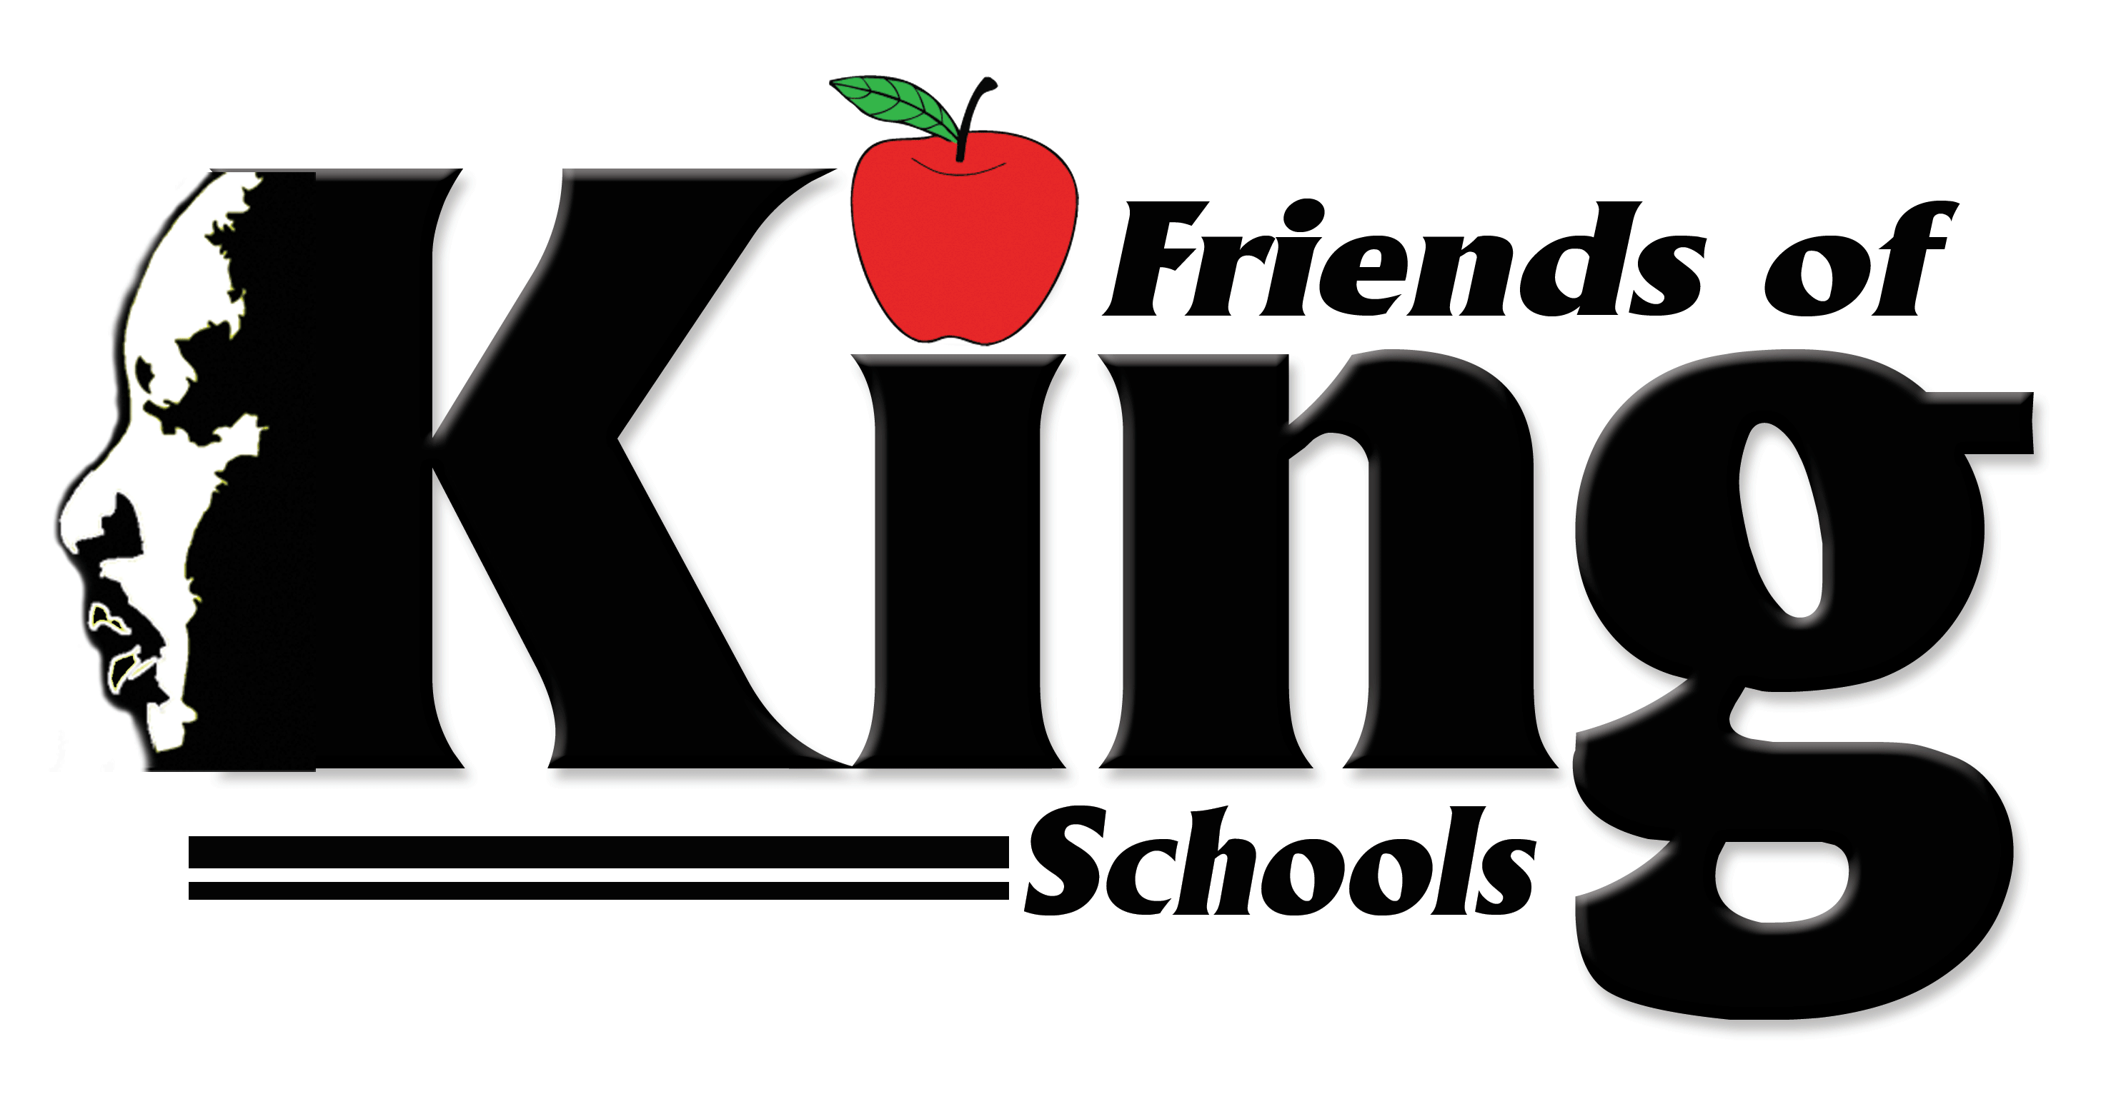
The Friends of King School Board meetings are held every other month on the second Tuesday at 12 noon. A schedule of meetings, agendas and minutes can be found on the district’s website. www.friendsofking.com. Please contact SELLISON@MLKNOLA.ORG for board inquires.

Date(s) Time
08/13/2024 12 NOON
*09/10/2024 12 NOON
11/12/2024 12 NOON
01/14/2025 12 NOON
03/11/2025 12 NOON
05/20/2025 12 NOON

*Denotes Special Board meeting being held.

